Using GPIO in Vortex86EX SoC
2014-11-12

80 GPIO pins are provided by the Vortex86EX for general usage in the system. All GPIO pins are independent and can be configured as inputs or outputs; when configured as outputs, pins have 8 mA drive capability and are unterminated; when configured as inputs, pins are pulled-high with a 75k ohm resistance. Refer to Vortex86EX functions block diagram:

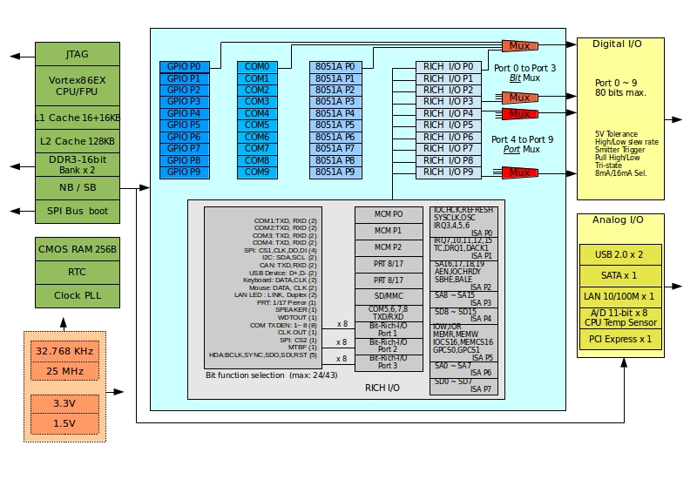

Setup GPIO Direction

Here is GPIO direction and data registers:
 | Port 0 | Port 2 | Port 7 | Description
Data Register | 78H | 7AH | 102H
Direction Register | 98H | 9AH | 94H | 0: GPIO pin is input mode  1: GPIO pin is output mode

If send value 0FH to port 98H, it means that GPIO port0 [7-4] are input mode and port[3-0] are output mode.

If send value 00H to port 98H, it means that GPIO port0 [7-0] are input mode.

If send value FFH to port 98H, it means that GPIO port0 [7-0] are output mode.

If send value 03H to port 98H, it means that GPIO port0 [7-2] are input mode and port[1-0] are output mode.

Linux Example

#include <stdio.h>

#include <stdio.h>
#include <sys/io.h>
#define outportb(a,b) outb(b,a)
#define inportb(a) inb(a)

void main(void)
{
iopl(3);

/* set GPIO port0[7-0] as input mode */
outportb(0x98, 0x00);

/* read data from GPIO port0 */
inportb(0x78);

/* set GPIO port2[7-0] as output mode */
outportb(0x9a, 0xff);

/* write data to GPIO port2 */
outportb(0x7a, 0x55);

/* set GPIO port7[7-4] as output and [3-0] as input*/
outportb(0x94, 0xf0);

/* write data to GPIO port7[7-4], the low nibble (0x0a) will be ignored */
outportb(0x102, 0x5a);

/* read data from port2[3-0] */
unsigned char c = inportb(0x102) & 0x0f;

}

Technical Support

For more technical support, please visit http://www.dmp.com.tw/tech or mail to soc@dmp.com.tw.

